January 7, 2022 melanie.meredith@parisisd.net

Crockett Intermediate School Science Fair Winners

Crockett Intermediate School’s Science Fair winners were announced today. The winners from left are:

Ryan Macchia – 1st place – Angles of the Blade

Kaleb Yarbrough – 2nd place – Triangle Countdown

Grey Gillem – 3rd place - Blue Light: Sleep Tight

Tressie Cochran (not pictured) – 4th place – What Plant Grows the Fastest: Aloe Vera, Succulents, or Parlor Palm?

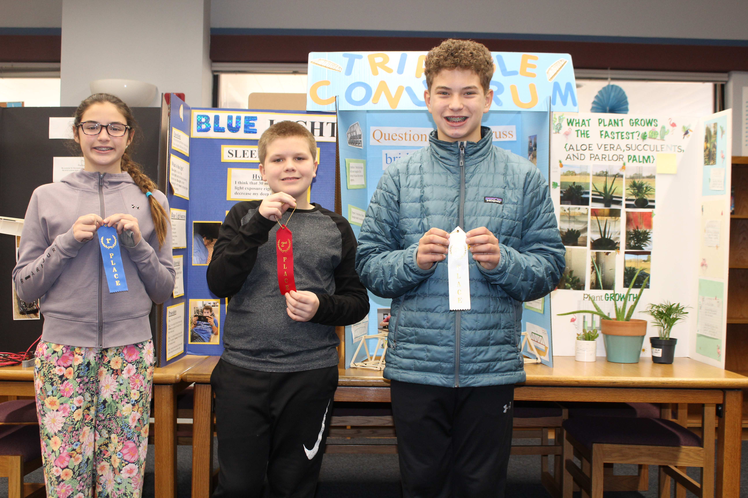Winners will compete in Region 8 ESC Science Fair on February 4th.

