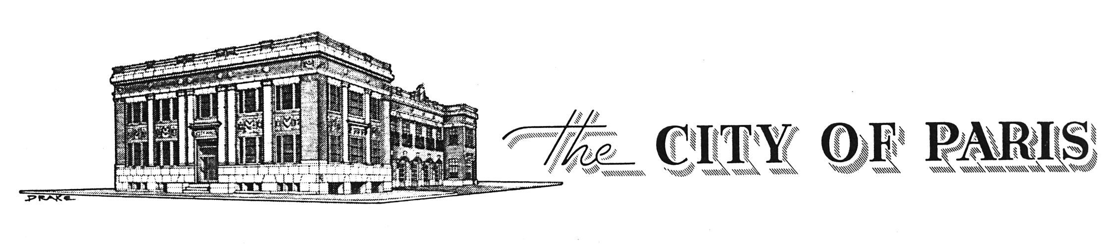
March 1, 2023

RE: Tax Credit Seminar

Dear Historic Downtown Building or Business owner,

The Historic Preservation Office invites all building and property owners to attend a presentation on Federal and State Tax Credits, and how they can be used as a funding source for a rehabilitation of historic buildings. The date for this event is March 7, 2023 at 6:30 p.m. and located in the City Council Chambers, 107 E. Kaufman, Paris, Texas.

Austin Lukes, Texas Historical Commissions Program Specialist and Tax Credit Reviewer will be the facilitator. The presentation is free and public is everyone is invited to attend the brief presentation followed by a question and answer session. This workshop is expected to last 1 hour. Refreshments will be served.

Texas Legislature passed House Bill 500, which establishes a state tax credit for the certified rehabilitation of certified historic structures. Eligibility for the credit is based upon buildings listed in the National Register of Historic Places, either individually or as part of a historic district, or designated as Recorded Texas Historic Landmarks or State Antiquities Landmarks.

The Paris Historic Commercial District is listed on the National Register of Historic Places. Properties within this district could be eligible for the credit.

The credit is worth 25% of the eligible rehabilitation costs for the project, which must be at least $5,000 in value to qualify. Many projects have sought to pair the state tax credit with the federal 20% tax credit for rehabilitation which is available for the rehabilitation of historic, income-producing buildings that are listed in or determined eligible for listing in the National register for Historic Places.

Most rehabilitation costs qualify for the credits, such as structural work, building repairs, electrical, plumbing, and heating and air conditioning, roof work, and painting. Architectural and engineering fees, site survey fees, legal expenses, development fees, and other construction-related costs are also qualified expenditures if such costs are reasonable and added to the property basis.

This incentive is one of many opportunities to fund a renovation project. The City of Paris offers Tax Exemptions for the Rehabilitation of Historic Properties, Façade grants and the Building Improvement Grant. To find out more visit Paristexas.gov.

To RSVP for the workshop, e-mail Cheri Bedford cbedford@paristexas.gov or call 903-784-9293.

